Description:

The entity generates a trigger and data signals according the chosen scene, the user chose one of different scenes that are defined in the entity (we have 5 scenes for now).

The internal output data is a cyclic counter that change from 0 to 2^record_depth_g, but we can also get the data and trigger signals from an external source.

Generic table

|  |  |  |
| --- | --- | --- |
| Name | Width | Description |
| reset_polarity_g | 1 | '1' reset active high, '0' active low |
| record_depth_g | 4 | number of bits that are recorded from each signal is 2^record_depth_g |
| data_width_g | 8 | defines the width of the data lines of the system |
| num_of_signals_g | 8 | number of signals that will be recorded simultaneously |
| external_en_g | 1 | 1 -> getting the data from an external source . 0 -> dout is a counter |

Signals table

|  |  |  |  |
| --- | --- | --- | --- |
| Name | Direction | Width | Description |
| clk | In | 1 | System clock |
| Reset | In | 1 | System reset |
| scene_number_in | In | data_width_g | The trigger output scene |
| scene_valid | In | 1 | 1 ->sample trigger scene. 0 -> other |
| data_in | In | 1 | External data in |
| trigger_in | In | num_of_signals_g | External trigger in |
| generator_finish | in | 1 | 1 -> stop output data. 0 -> other |
| data_out | Out | num_of_signals_g | Output data |
| trigger_out | Out | 1 | Output trigger |

Signal generator state machine

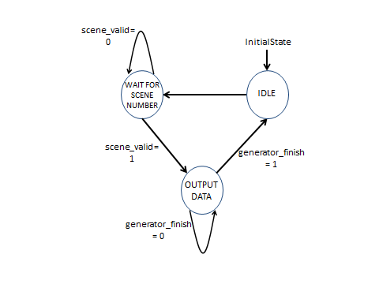

Output table

